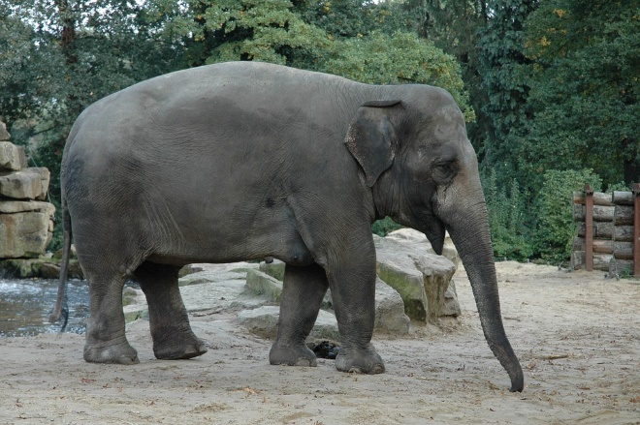 bidlo

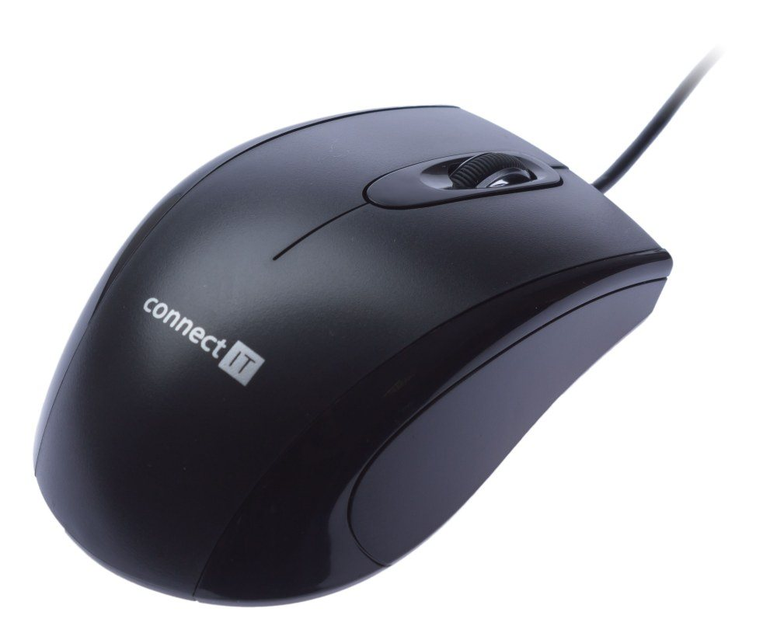ka

ob

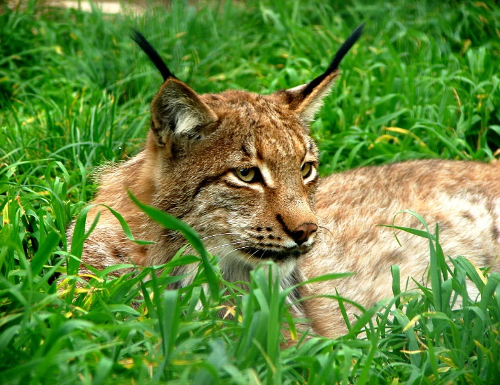

[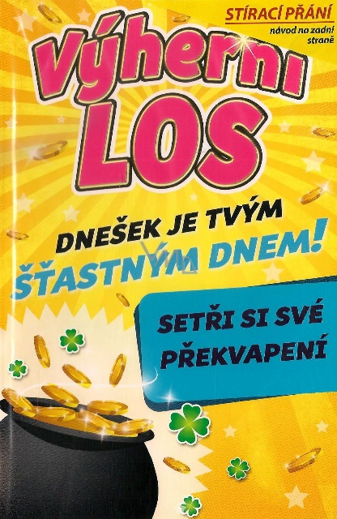](https://www.google.cz/url?sa=i&url=https%3A%2F%2Fwww.vmd-drogerie.cz%2Fnekupto-stiraci-prani-k-narozeninam-vyherni-los-g-46-3353-21-5-x-13-5-cm%2F&psig=AOvVaw1wPx_0fnXjfp498xBghc_9&ust=1585676853107000&source=images&cd=vfe&ved=0CAIQjRxqFwoTCNiQ2O3gwugCFQAAAAAdAAAAABAD) os

un

